Sai Omkar Kandukuri, Advanced stats PS 2

1. C = 1/3 , Mean = 0 , Variance = 5/6

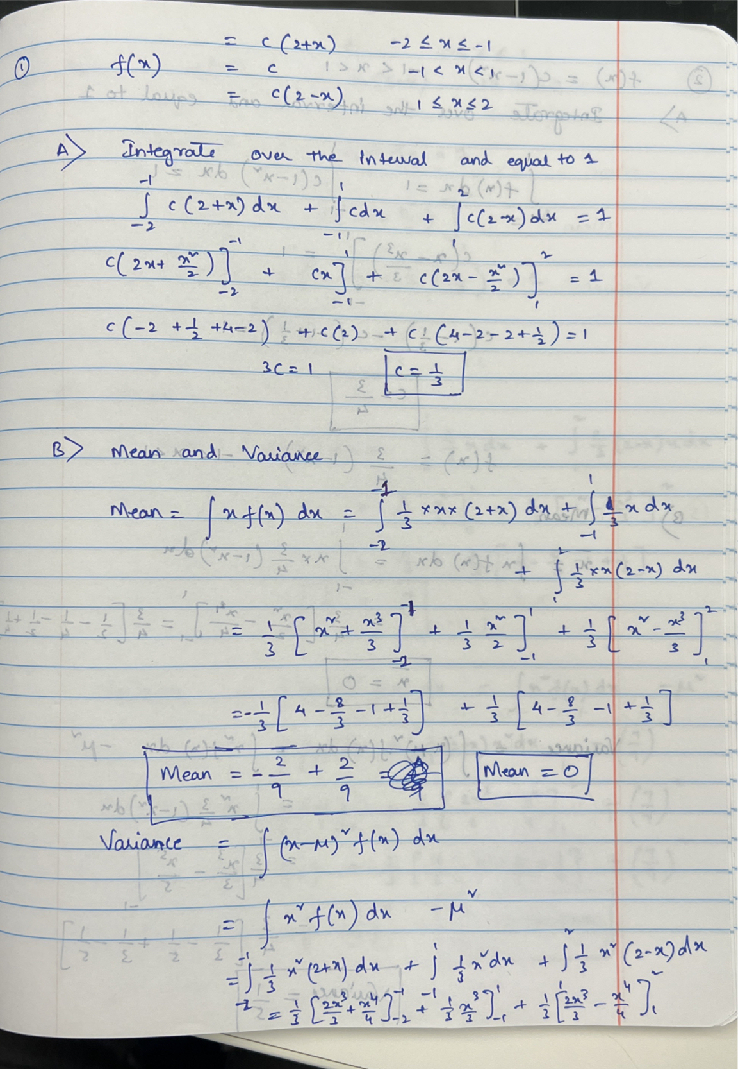

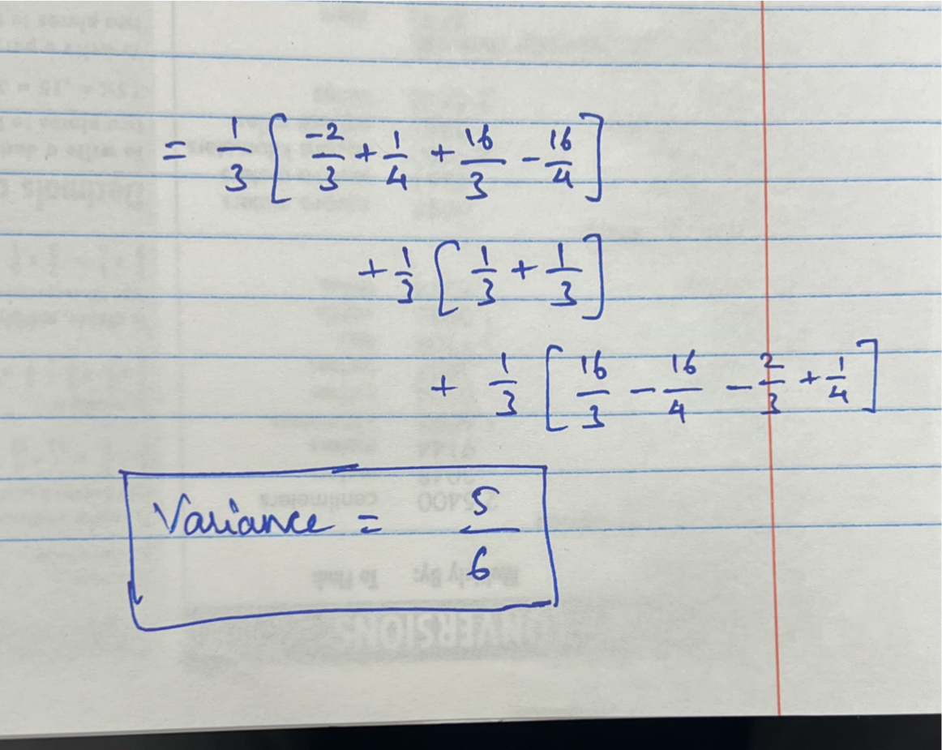

1. C = ¾ , Mean = 0 , Variance = 1/5

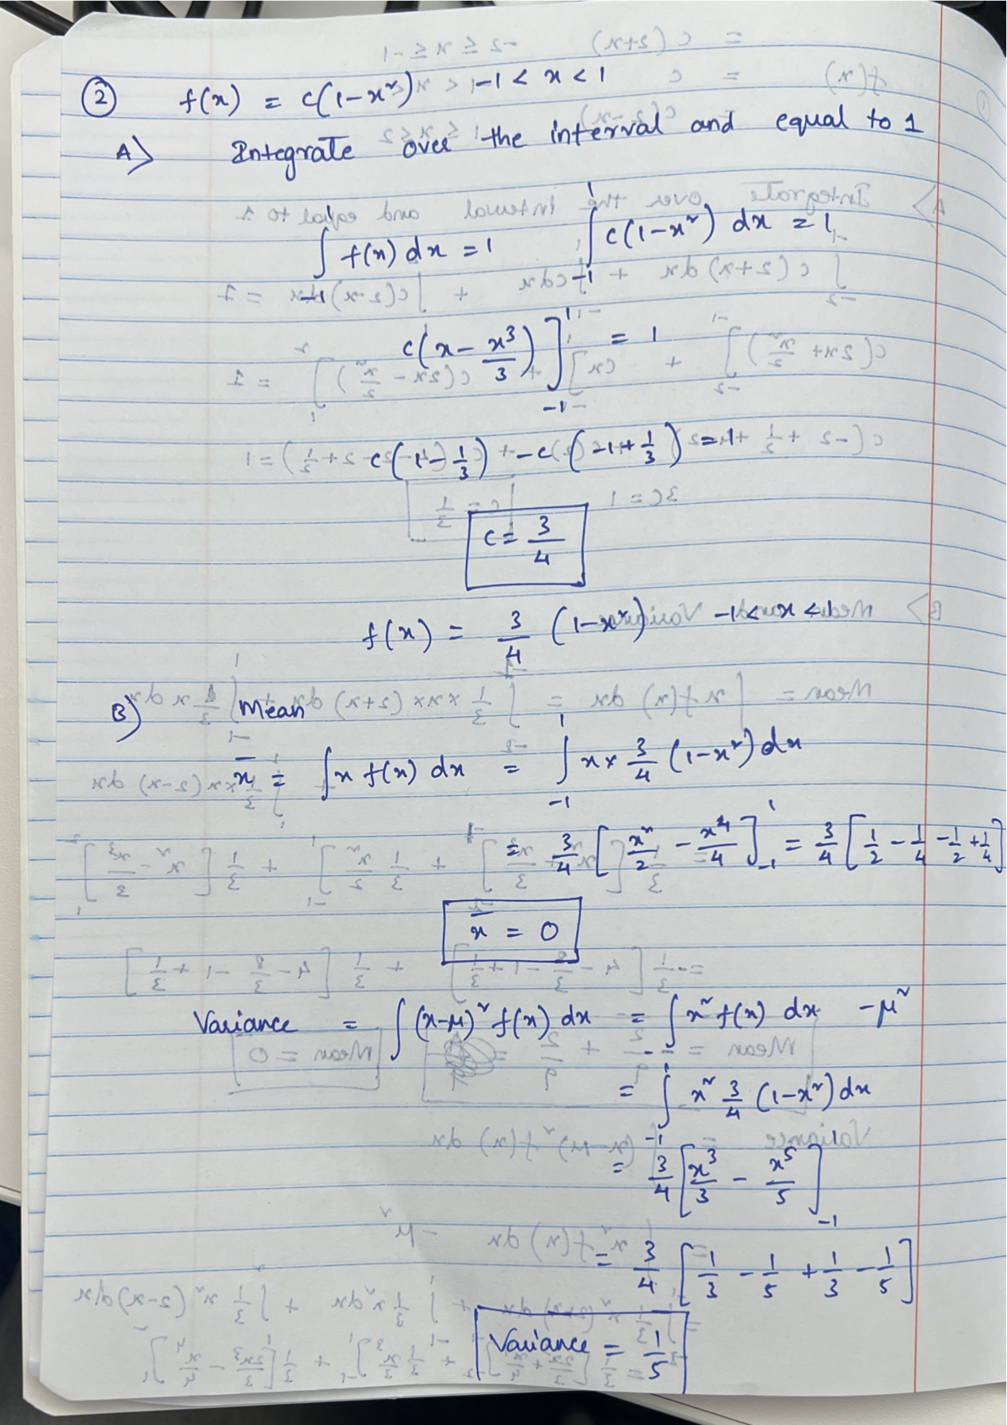

1. C = 2/3, Mean = 7/9, Variance = 37/162

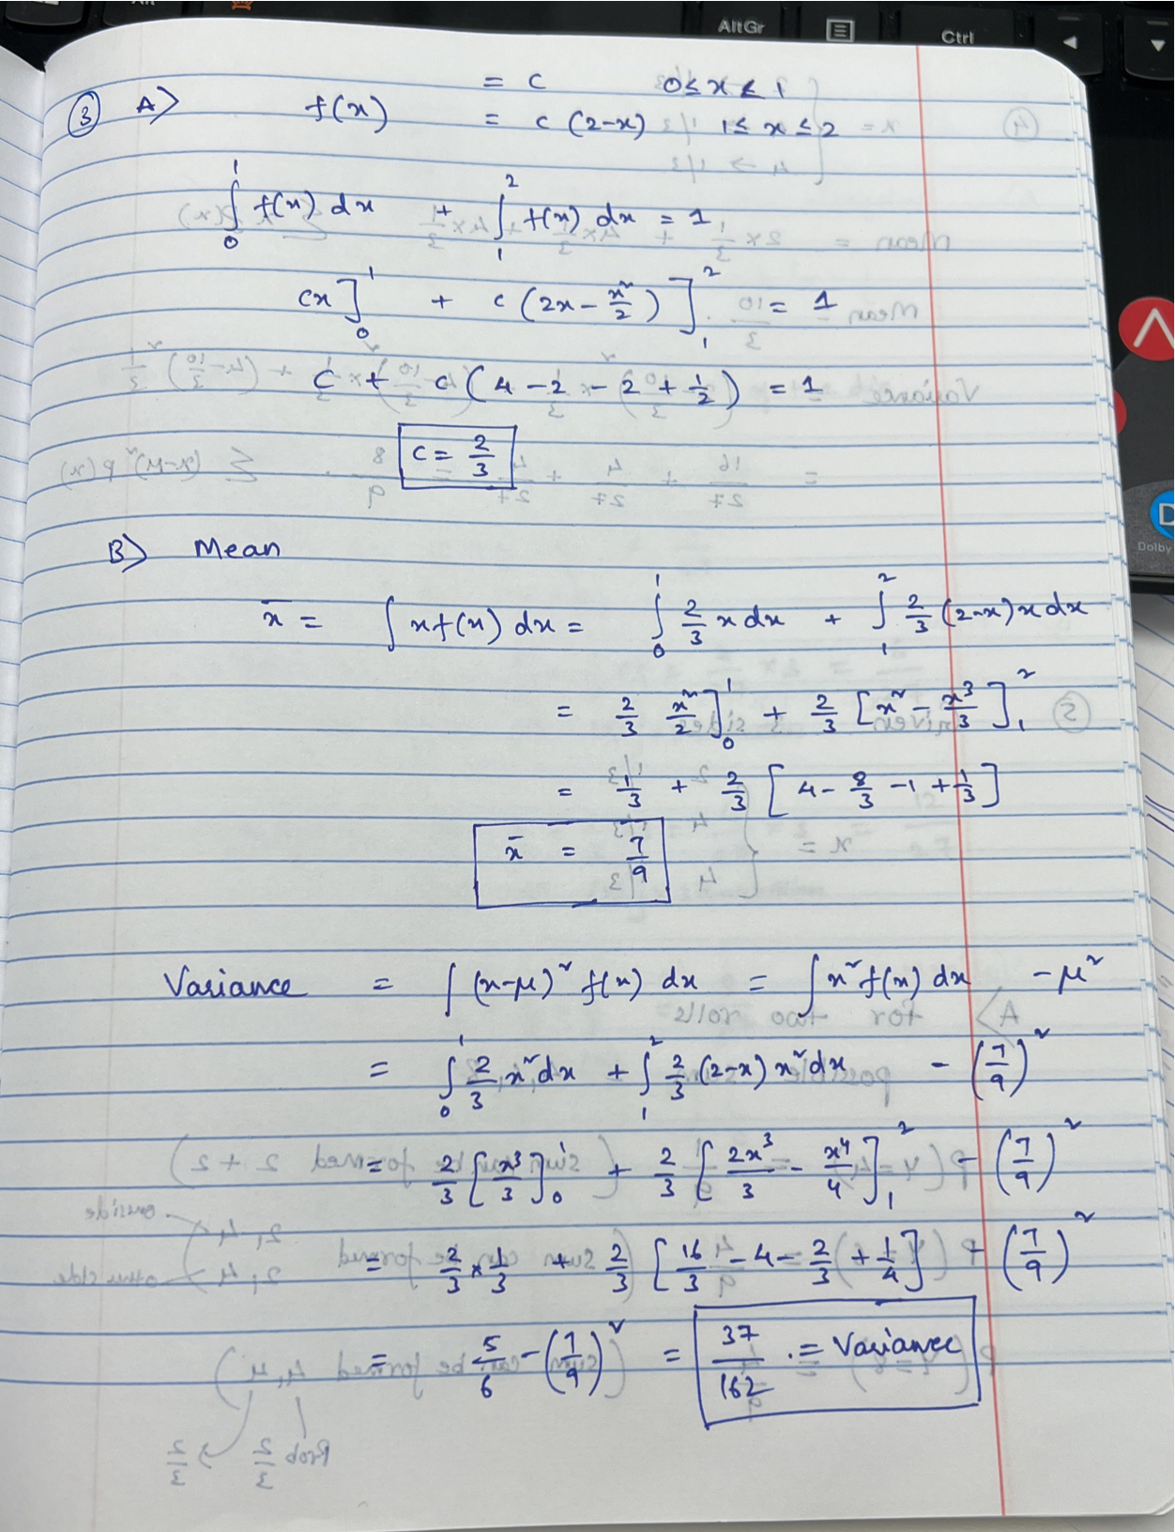

1. Mean = 10/3, Variance = 8/9

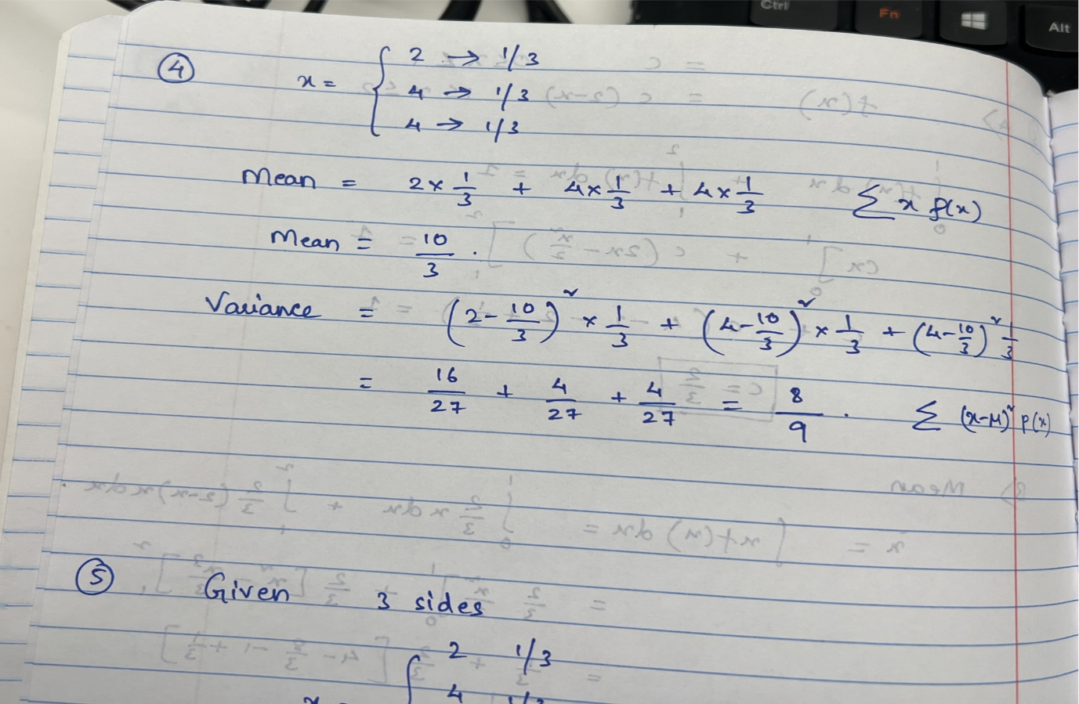

1. A) PMF -> {4: 1/9, 6:4/9, 8:4/9}

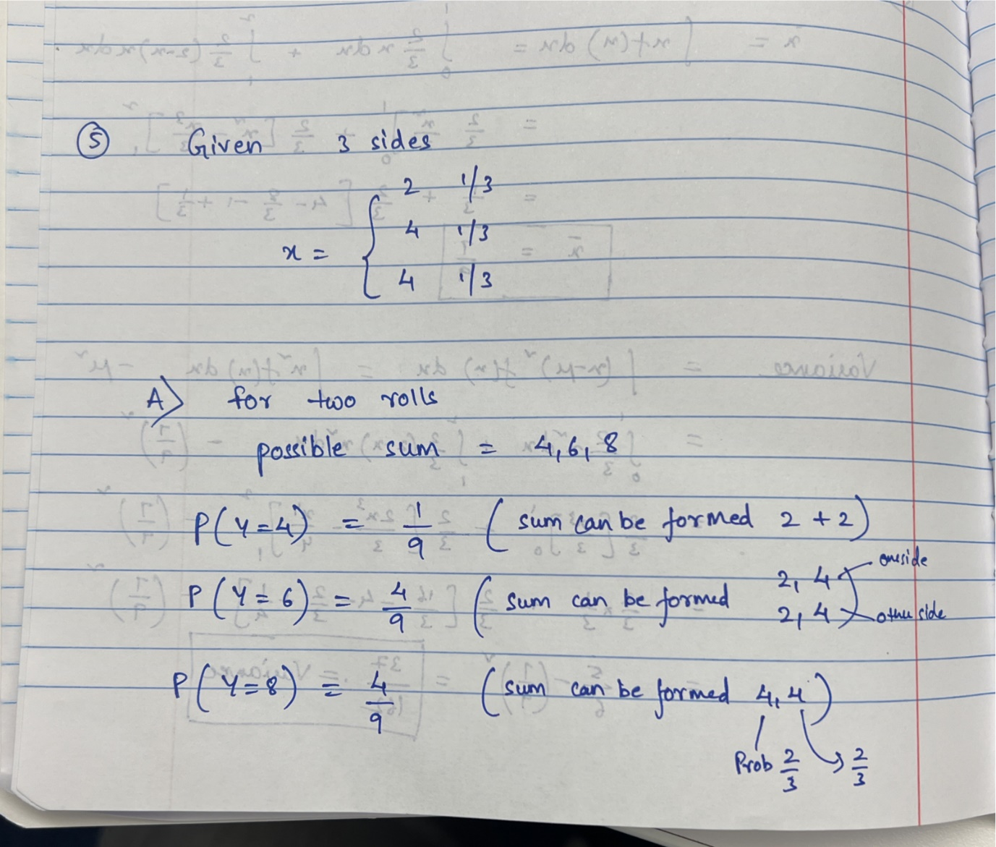

B) PMF {6:1/27, 8: 6/27, 10:12/27 , 12:8/27 }

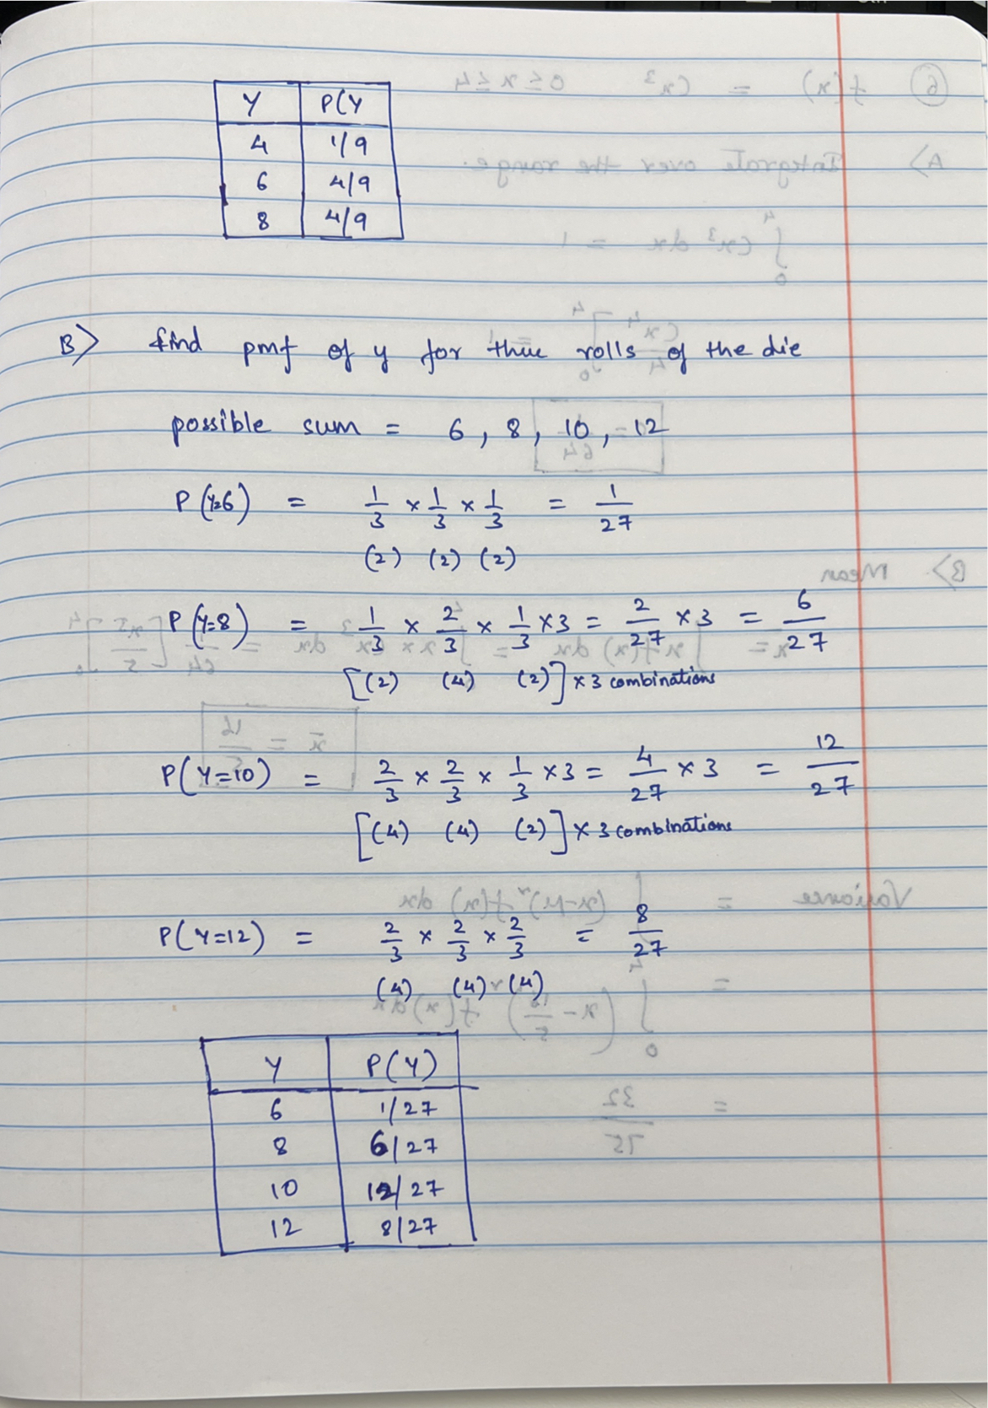

1. C = 1/64, Mean = 16/5, Variance = 32/75

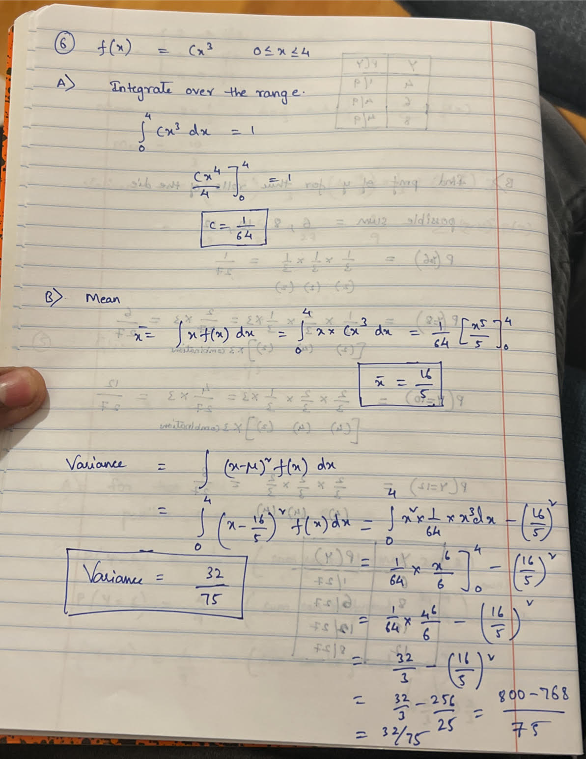

1. Part A : R (.rmd , knitted pdf) and Stata(.do and .log) files uploaded

Part B : Calculation below, similarly calculated the same in R

